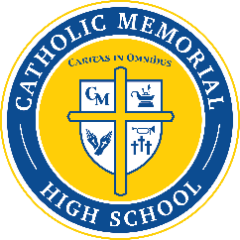
Catholic Memorial Parents’ Club (Formerly Mother’s Club)
Membership 2022-2023

Names:___________________________________________________
Cell:_____________________________________________________
Email:____________________________________________________
CMH Alum: Yes and Year____ No_____
Student(s) Name and Grade:__________________________________

Membership Fee: $40 (Click QR Code to pay online) or make check payable to CMH Parents’ Club

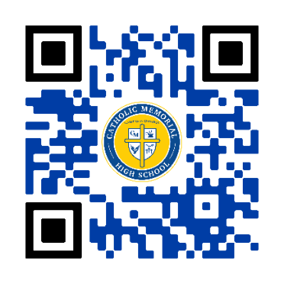

Some ways to maximize your membership:
- Attend social events sponsored by Parents’ Club
  - Freshman and New Parents’ Mixer – 9/26 @ 6:45pm in the ARC
  - Fashion Show and Luncheon – 3/26 @ Marriott West
  - Father / Son Social – 11/13
  - Mother / Son Dinner Dance – 4/1
  - Father / Daughter Dinner Dance
  - Various socials throughout the year for Parents
- Volunteer if able (not a requirement) at various sponsored events
- Other benefits:
  - Receive a CMH Family Directory – contact information for families
  - Parents’ Club Christian Service Scholarship for Seniors

A Parents’ Club Member will contact you to welcome you and answer any questions!

Mission: We the Catholic Memorial Parents’ Club exists to provide social activities and service opportunities for the Catholic Memorial family, and financial support for Catholic Memorial High School. We believe parent-student social events encourage a sense of community within the Catholic Memorial family. We believe service activities challenge young people to answer the call of their Catholic faith. We believe our financial commitment assists Catholic Memorial High School in offering educational excellence to all students

